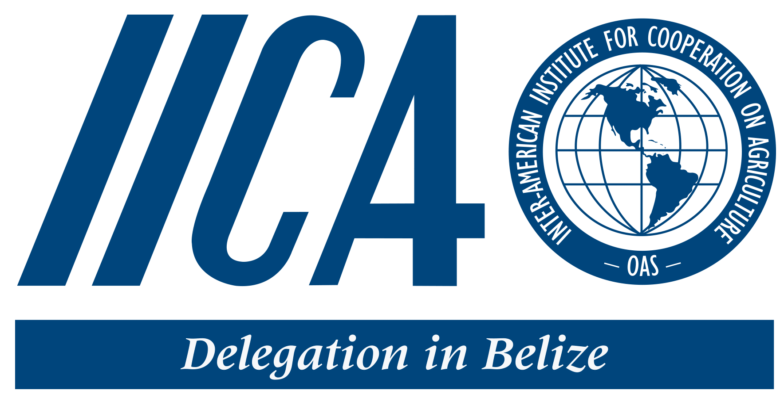

Five Year Strategy to
Create an Enabling Environment
that will
Transform Beekeeping
into a Viable, Eco Friendly and Profitable Industry

2019 to 2024

DRAFT June 2019

2019
Preface
Table of Contents
List of Figures and Tables

Table of Contents:

- Introduction
- Profile of Beekeeping in Belize
- Industry Challenges
- Strategic Goals and Pathways
- Strategic Objectives
- Methodology/Theory of change
- Key Stakeholders
- Implementation Plan

Introduction

This Strategy
This document presents a strategic plan to establish a successful Beekeeping industry under Belize’s agriculture and food sector. The document’s main goal is to present a framework of outcomes that when achieved will “create an enabling environment to transform beekeeping into a viable, eco-friendly and profitable industry that positively impacts the livelihoods of rural farming communities.” The plan identifies issues, along the beekeeping value chain, that need to be addressed under four main components: (i) policy; (ii) inputs and finance; (iii) production; and (iv) market and thereby provides a framework for the development and implementation of actionable projects to address those issues.

Government Policy
The Agriculture and Food Sector is one of the main pillars of the Belizean economy, contributing significantly to Gross Domestic Product (GDP) (13.06%), employment (17.9%), income generation, and food and nutrition security. This sector is also important to macroeconomic growth and development as it is a major earner/saver of foreign exchange.

The Growth and Sustainable Development Strategy of the government of Belize places great emphasis on sustainable development. In its Necessary Condition 1.3.2 it focuses on optimal economic transition: supporting new and emerging activity with good prospects. Beekeeping/honey enterprises have that potential to become competitive and become a significant contributor to the national economy.

Belize’s Ministry of Agriculture has identified beekeeping as one of its priority areas for growth. The development of this beekeeping strategy and its implementation through a value chain approach support strategic objective 1.2 of the Agriculture and Food Policy, 2015-2030: to support the development of strategic agriculture and food value chains.

The ministry recognises the beekeeping industry’s potential, through rural on-farm diversification, to alleviate poverty, increase food security and improve crop yields by: (i) enhancing rural income opportunities (especially for women and youth) by providing access to a potentially lucrative market for honey and beekeeping products; (ii) improving family farm nutrition; (iii) providing traditional health care remedies; and (iv) providing crop pollination services (e.g. to the currently expanding coconut industry). In the longer-term, there is great potential for beekeeping to make a significant contribution to the economy of Belize by providing employment opportunities among rural communities and by increasing foreign exchange earnings through honey exports. It is also noted that beekeeping has a very low environmental footprint and, indeed, has the potential to positively contribute to environmental conservation and sustainable development.

Economic Impact
Beekeeping and honey production was a significant industry for Belize in the 1980s but declined significantly, soon after, because bee keeping became more challenging. This was because of the arrival of the aggressive Africanized bee strains and the use of toxic herbicide spray programmes, to control cannabis plantations, that negatively impacted bee populations. However, with adequate capacity building for beekeepers, and improvement in support services and investments in strategic areas the industry is well positioned to make a comeback.

Recent estimates are that Belize has just under 100 beekeepers, managing around 2,000 hives and producing an average of 93,000 lbs of honey a year up to 2018 with an average production of around 47 lbs per hive per year. A well-managed hive of optimum productivity would be expected to produce an average of 60 lbs of honey a year. This implies that Belize is performing well below optimum capacity. At current productivity, the current estimated yearly total revenue for beekeepers in Belize is around BZ$620,000 (at retail price). A 100% increase in productivity would therefore result in a doubling of earnings from honey production - to BZ$1.2 million. This does not include the potential for value addition.

To ensure sustainable growth in the industry a robust plan, that is supported by a stable investment environment, that can not only enhance hive productivity but also stimulate apiary expansion, is required.

2. Profile of Beekeeping in Belize

Recent estimates (2018) are that Belize has just over 100 beekeepers, managing a little more 2,000 hives and producing an average 93,000 lbs of honey a year. There has been a significant increase in production in the last year, increasing from an average of 88,000 lbs between 2014 to 2017 to a production of 113,000 in 2018 (Figure 1). This is an increase of over 30,000 lbs in one year. In the 1980s Belize was producing from five active beekeeping cooperatives, managing between 10 to 11,000 hives, and producing approximately 700,000 lbs (318,000 Kg) of honey a year, much of which was exported. Honey production was an important and lucrative industry for the country and beekeepers. Soon after this peak in production, however, bee populations suffered adverse effects and probably was decimated by herbicide spraying programme and with the arrival of the more defensive Africanized strain of bee many beekeepers abandoned honey production as a farming activity. Since that time, the Africanized bee, which is more productive, has cross-bred with the more placid European strain, to produce a bee with characteristics of relatively high productivity and moderate defensiveness. Some beekeepers assert that Africanised bees are superior honey producers and more effective pollinators.
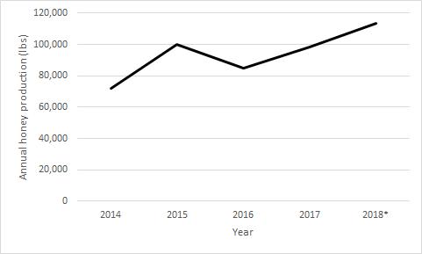
Figure 1. Total honey production in Belize 2014 to 2018

Despite a potentially lucrative market for beekeeping products and a more productive bee now present in Belize, farmers are slowly adapting to managing Africanized bee strains and consequently the total annual honey production is slowly increasing (figure 1). Although honey production has not yet returned to the peak of the 1980s, beekeeping as an alternative income source has great potential. A national survey of apiaries carried out in July 2017 by the Ministry of Agriculture revealed that the average honey production per hive is 47 lbs. which is below regional industry average of 60lbs. It also showed that Orange Walk District had the highest productivity, but the Cayo District had the most beekeepers and the highest production. Twenty-five colonies well managed and with optimum production are considered to be the minimum for an economically sustainable operation. The survey revealed that most beekeepers have 10 or less colonies.

3. Current Challenges in the Honey Sector

The honey industry in Belize, is faced with countless challenges that must be overcome if it’s to become a viable one. Recent surveys carried out by the Ministry revealed that the industry is mostly hobby type bee keeping with the majority of beekeepers having limited numbers of hives. Beekeepers currently manage apiaries with and average range of 10 to 15 hives. Productivity has remained constant despite the increase in the number of hives and can be attributed to inadequate management practices of the new strain of honey bee (Africanized), lack of a technical assistance programs, loss of habitat, and the exposure to the use of pesticides in agricultural production. Beekeepers are also facing competition from cheaper illegally imported and even adulterated honey.

The challenges to the industry are widespread and numerous, as such the creation of this industry development guiding document has taken a value chain approach to the development of strategies. Initially the several components of the value chain have been separated (correlations maintained) to allow for a deeper and more detailed analysis, this in turn has lead to the development of strategic interventions under each component. The main components of the beekeeping value chain are as follows
- Policy and governance framework
- Inputs Supply and Finance
- Production and Management
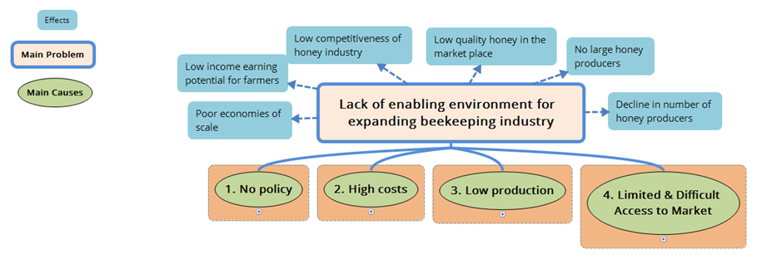
- Market access

Figure 2. Main Challenges of the Beekeeping Industry

The main challenges with in the different links of the Beekeeping Industry value chain are as follows:

- Policy and Governance
The lack of a Policy framework that guides the development of the beekeeping industry is a main constraint to the development of the industry. There is the need to develop beekeeping with its links to the environment, social and economic development of Belize. There is the need for the revision of the current legislative framework to allow it to foster the development of the industry as a means of diversified livelihood opportunities focused on rural communities with special focus on the engagement of women and youth. The legal framework additionally should safeguard the industry by creating the enabling environment for growth and development of the sector. There is much need for the strengthening of the enabling institutional stakeholders such as the extension service of the Ministry of Agriculture, the Belize Agricultural Health Authority and the cooperatives Department to provide the necessary services for the growth and development of the industry.

Challenge
- No overarching policy and governing structure for the Industry
- Outdated regulatory framework for the beekeeping industry

2. Input Supply and Finance
Beekeepers as most farmers in the agriculture sector, face challenges with limited access to investment capital. Lack of access to finance is also a reflection of the lack of a policy framework. Financial institutions are reluctant to provide investment capital at competitive rates due to limited understanding of the industry. Furthermore, limited access to beekeeping materials and equipment can be mainly attributed to poor supply mechanisms and cooperative acquisition as well as poor government taxation schemes for the promotion of industry growth. .

Challenges
- Import tax regulations and supply chains for inputs makes establishment and maintenance of beekeeping operations costly and threatens long-term business sustainability
- Limited access to capital at competitive interest rates due to limited understanding of profitability of honey production by lending institutions.

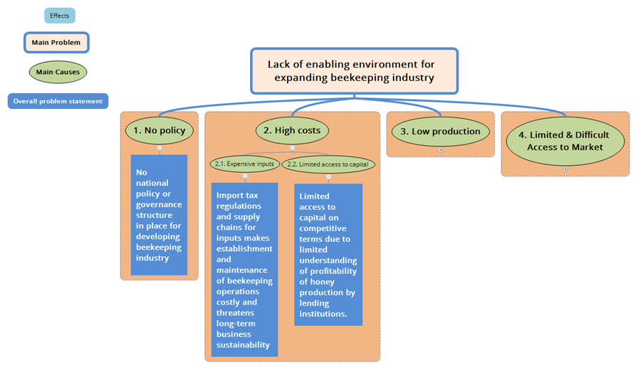
Figure 3. Overall Problem Statements for Policy and Input Supply Challenges
3. Production and Management
Currently the Ministry of Agriculture doesn’t count with any technical program for the promotion and support for the beekeeping subsector. There is a poorly organized beekeeping industry with little knowledge in the management of the Africanized bees or initiatives to improve the genetics, overall low productivity and lack of capacity to mitigate effects of pest and disease and other natural phenomenons.
Additionally there is a lack of good governance and management of organized groups to do business. There is much needed support for the strengthening of support organizations such as Cooperatives Department and BMDC for the promotion of beekeeping with a business orientation.

Challenges
- Poor governance and organizational structures that support producer groups require strengthening to improve services and attract membership
- Limited entrepreneurial and business skills to develop honey production enterprises
- Lack of protocols and concessions to promote beekeeping in forest and protected areas
- Lack of system to promote agreements between beekeepers and farmers
- Lack of insurance system to compensate beekeepers in the event of hive damage or theft
- Limited understanding regarding behaviour and benefit of bees
- Limited understanding and concern of impacts of poor agricultural practices on beekeeping.
- Poor bee genetics (access) and poor hive management contributes to low productivity
- Limited administrative and technical support for beekeeping sub-sector

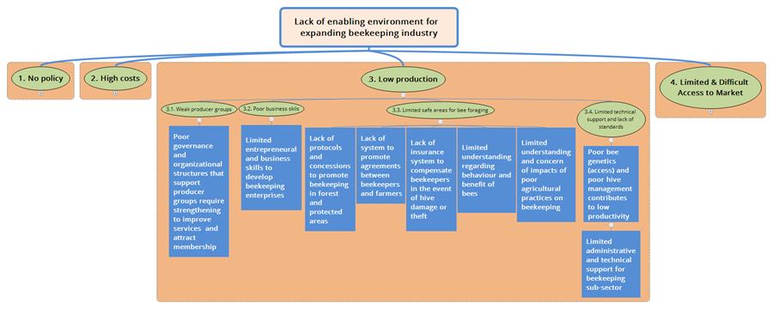
Figure 4. Overall Problem Statements for Production Challenges
4. Market Access
The Market access component is subdivided into four main areas, these are the Processing, Packaging, Distribution and Promotion, and Consumer. A key weakness in the industry that also presents itself as an opportunity is in value addition and business orientation. The market linkages are weak and there is no support mechanism to protect producers from the ailments of the market and its disturbances. Additionally the Local Honey Standards are not being applied and there is no regulatory mechanism or well equipped entity to safeguard the quality and integrity of honey and other beekeeping products. Moreover, consumers and the general public need to have heightened awareness of the benefits of the sector to the health and well being of the general populace, the environment and the socio economic contribution to the country.

Challenges
- Limited entrepreneurial mind set and limited access to technical expertise in value addition and certified storage and processing facilities
- Limited access to innovative consumer attractive - cost effective packaging and labelling that meets the national standards
- No mechanism to enhance linkages between producers and markets.
- Lack of mechanisms to mitigate unfair competition with illegal and like products.
- Limited awareness and promotion of good quality beekeeping products among local consumers.
- Lack of certification programme to guarantee quality beekeeping products
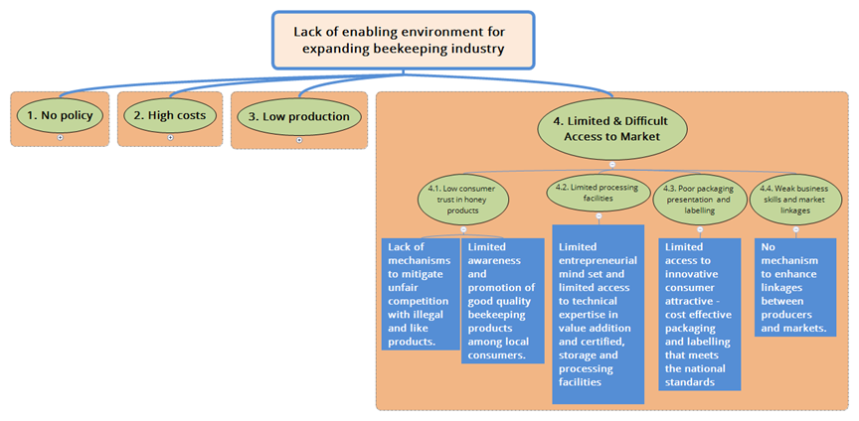
Figure 5. Overall Problem Statements for Market Challenges

4. Beekeeping Industry Five Year Strategy – 2019 to 2024

The long-term aim of the beekeeping strategy is to create:

An enabling environment that has transformed beekeeping into a viable, eco-friendly and profitable industry that positively impacts the livelihoods of rural farming communities.

The long-term impacts of this strategy will be that:

- Farmers have enhanced beekeeping business skills and experience beekeeping as a viable and interesting business opportunity for enhancing their income and therefore establish new or continue with current beekeeping businesses.
- Livelihoods of rural communities have been enhanced
- Greater quantities of quality honey are sold in the Belize marketplace
- Belize is known for quality honey
- Honey is exported from Belize.

This strategy will be implemented through four pathways that will bring about change, each tackling the areas highlighted below with the main outputs.

- Policy pathway outcome – a supportive national policy and governance structure.
- Inputs and finance pathway outcome – affordable inputs and financing.
- Production pathway outcome – apiary productivity and national honey production increased.
- Market pathway outcome – dynamic, profitable and accessible market for diverse range of quality beekeeping products.

Each pathway has a set of outcomes that will lead to the above final long-term outcome.

5. Strategic Objectives

To ensure the sustainable development of the industry the following strategic objectives must be fulfilled;
The main components of the beekeeping value chain are as follows
- Policy and governance framework
- Inputs Supply and Finance
- Production and Management
- Market access
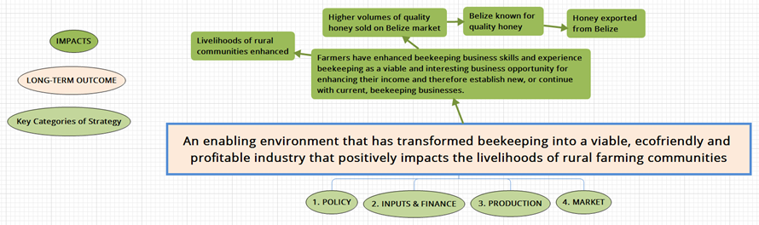
Figure 6. Beekeeping Industry strategy, main goal its impacts, and components
The Strategic objectives and outcomes with in the different components of the Beekeeping Industry value chain are as follows:

1. Policy and Governance Framework
The formulation of a Policy for the beekeeping sector will support the industry in the creation of support systems for the management of the sector, establish a code of conduct, clarify roles and responsibilities of sub sector stakeholders, address conflicts between beekeeping and other sectors, promote fair practices, establish guidelines for production, promote ethics and standards in business as well as ensure sustainable and prudent utilization of forest resources. The Government through the ministry of agriculture is the entity responsible to develop and promote such policy direction in consultation with the value chain stakeholders.
Strengthening the governance structure and other supporting mechanisms of the beekeeping industry is vital for the creation of a strong enabling environment. Investment and growth in the industry will be brought about when there is more organization with in the sub sector and coordination between the sub sector stakeholders. The various stakeholders with in the value chain and the value chain committee are the main entities responsible for the promotion of governance structures with in the subsector.

SO1.1 To develop and implement a policy and strategic plan for creating a viable eco friendly beekeeping industry

Main Outcomes
- Supportive national policy and support structure
- Bee Act revised and adopted into law
- GOB and MOA adopt Beekeeping policy and governance structure
- The strategy reviewed, revised and approved by beekeepers and MOA
- Value chain committee and district advisory committees established to oversee and guide industry development, operations and implementation of this strategy

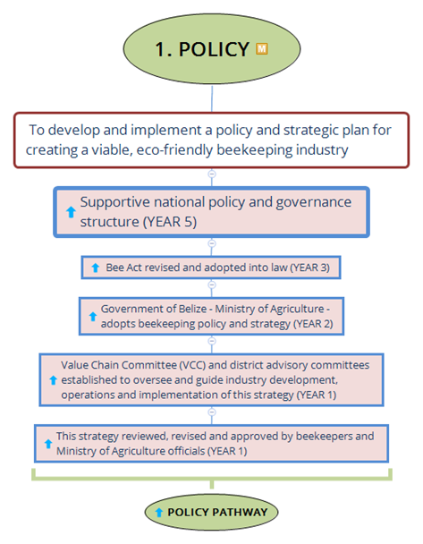

Figure 7. Main outcomes and pathway to achieve the policy strategic objective

2. Inputs Supply and Finance
improvement on the supply of inputs will greatly enhance the field practices and the use of proper management systems for the production of beekeeping products. The relative high initial investments in tools and equipment by small producers will be circumvented by creating access to affordable capital through the financial sector. It will be crucial to prepare and build the capacities of value chain actors though entrepreneurship development in order for them to be in a position to successfully access financial institutions. A more comprehensive understanding of the sub sector and its profit potential will assist in facilitating the access to investment capital.

SO2.1. To ensure long term business sustainability of beekeeping operations through more favourable import tax regulations and efficient production systems and improved input supply chains

Main Outcomes
- Beekeepers access affordable equipment and input supplies
- Supply chain for beekeeping equipment and inputs improved to increase access and affordability
- Favourable tax regime to ensure affordability of beekeeping inputs (including packaging and labeling materials)

SO2.2. To Improve access to capital with competitive interest rates

Main Outcomes
- Beekeepers and value-add entrepreneurs access capital for their businesses on competitive terms
- Beekeepers and value-add entrepreneurs are aware of how they can access capital for their business and have the skills to manage that capital
- Banks and other lenders are willing to finance beekeeping operations on competitive terms

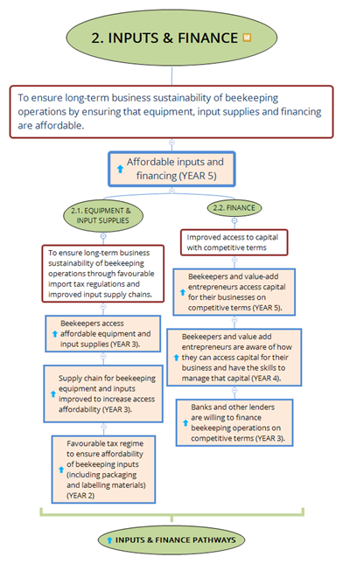
Figure 8. Main outcomes and pathway to achieve the inputs and finance strategic objective

3. Production and Management
Increase in production and productivity will be attained by the coordinate implementation of several actions by the various stakeholders in this component of the value chain. A national capacity building program to enhance the technical capacity targeting technical staff from the various organizations under the ministry of agriculture in their respective focus areas as well as key farmers and other stakeholders throughout the various geographical zones of the country is to be effectuated.
Investment in Research & Development in beekeeping methods technologies and practices will be undertaken by institutions of higher learning and research institutes throughout the country. Research and investment on product development is to be undertaken by the private sector to create diversity as well as competitiveness of beekeeping products..
The establishment of viable and business oriented producer groups will be supported through provision of capacity development services by the business support entities of the government ministries. building leadership skills, governance and enterprise capacity of beekeepers will improve the efficiency, and strengthen the institutional and organizational capacity of the subsector. As such these small scale enterprises will be able to have a greater socio-economic impact on the country.
Effective biosecurity at all levels will be implemented to minimise risks from pests, diseases and undesirable species through the promotion and implementation of production standards of beekeeping and husbandry.
Coordination with other line ministries and managers of land and forest resources to establish access and maximize the use of suitable forest resources will allow for the sustainable expansion of the industry.

SO3.1 To enable governance and organizational structures to strengthen producer groups to improve services and attract membership.

Main Outcomes
- Strong producer groups that are promoted amongst beekeepers
- Beekeepers producer groups increase their membership and financial sustainability
- Beekeepers are keen to join producer groups as they recognize the benefits of membership
- Enabling governance structure to strengthen producer groups to improve services and attract membership
- Cooperatives act revised to include oversight and support for other producer groups

SO3.2 To create widespread entrepreneurial capacity and business skills to develop honey production enterprises

Main Outcomes
- Honey production businesses increase their production and profitability
- Enterprises with widespread capacity in production and business
- Increased number of beekeepers (including women and youth)

SO3.3 To increase access to forest and protected areas through implementation of protocols that promote beekeeping concessions in these areas.

Main Outcomes
- Increased activities in forest and protected areas.

SO3.4 To Establish systems that promote agreements for beekeeping on and neighbouring farms

Main Outcomes
- Reduced damage to bee populations and beehives
- Farmers adopt agricultural practices that are complementary with beekeeping and as a result there is increased integration between beekeeping and farming
- Reduced negative impact of pesticides on bees and beekeeping
- Reduced public fear of bees and increased understanding and appreciation of the behaviour and synergies between agriculture, environment, conservation and beekeeping

SO3.5 Established insurance, compensation and other systems to mitigate risks associated with beekeeping

Main Outcomes
- Beekeepers aware of and use systems established to mitigate against risks associated with beekeeping
- Established insurance and other systems to mitigate against risks associated with beekeeping

SO3.9 Establishment of a dedicated beekeeping unit for the provision of administration (in input supply chain facilitation) and technical support for beekeepers and to create access to quality bee genetics

Main Outcomes
- Majority of beekeepers meet national beekeeping standards for apiary management (including genetics and control of pest and disease)
- Beekeepers have access to a queen rearing facility and know how to manage and maintain quality bee genetics
- A dedicated model demonstration unit, for the provision of administration(input supply chain facilitation) and technical support for beekeepers established.

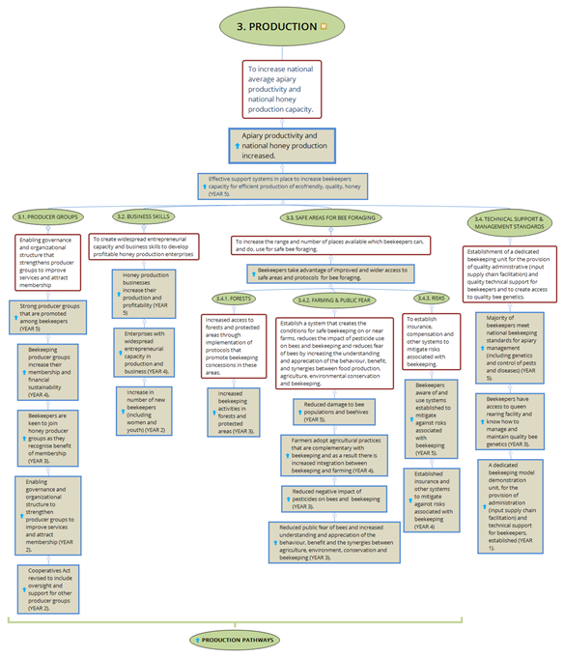

Figure 9. Main outcomes and pathway to achieve the production strategic objective

4. Market Access
Enhancing the industry's ability to access markets requires a holistic approach to the development of the industry. The market is the main driver of the value chain and as such by by investing in this component. This will require for other aspects of the chain to also be addressed. This strategy offers a particular focus in the development of entrepreneurial businesses, be it through groups or at the farmer level, diversification and value addition of beekeeping products will increase its demand and stimulate expansion of production.
The development of a well organized industry will also require investment in purchasing centers for bulk packing and the coordination between the stakeholders to facilitate its penetration to other markets. The strategy recommends the identification and support of model private sector processing and packaging firm/s to undertake commercial value addition. Efforts will be made to ensure traceability and geographical recognition during packaging of honey products. The enforcement of international quality standards for honey and bee products will increase the market access ability of the product. It will be important for enforcement of regulation through policy to be conducted, with the Government playing a leading role in strengthening the regulatory and monitoring agencies to allow the industry to meet the standards. The locally the strategy will facilitate the promotion of honey and value added honey products to create a knowledgeable and hungry for honey local market.

SO4.1 To ensure quality beekeeping products, produced in Belize, dominate the market.

Main Outcomes
- Public understanding of, and how to recognise quality honey increased
- Honey and value added products meet quality and food safety standards

SO4.2 Widespread access to certified packing and processing facilities

Main Outcomes
- Beekeepers use certified packing and processing facilities
- System (conformity assessments) to implement honey quality standards documented, established and implemented.
- BAHA capacity to provide required honey standard testing established
- Standards for honey quality testing and processing revised and adopted

SO4.3 Access to innovative consumer attractive cost effective packaging and labelling services and materials that meet national standards

Main Outcomes
- Widespread entrepreneurial capacity in beekeeping products processing, value addition, packaging, labeling and marketing.
- Honey processors have high capacity to produce and market, quality and attractive honey products that meet required standards for packing and labeling

SO4.4 To establish widespread entrepreneurial capacity in value addition, access to innovative consumer attractive packaging and labelling services and materials that meet national standards and to create strong linkages to the market.

Main Outcomes
- Strong market linkages established
- Use of honey in local culinary and tourist industry increased
- Improved systems to and to promote/sell beekeeping products at points of sale

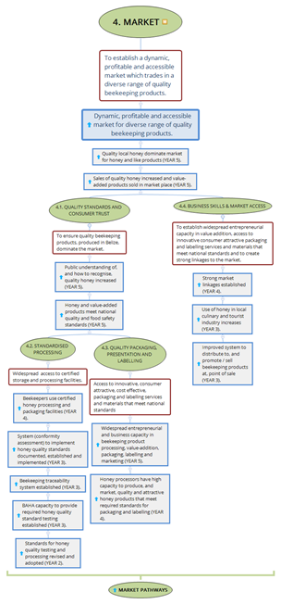

Figure 10. Main outcomes and pathway to achieve the market strategic objective

6. Theory of Change

Theory of Change is essentially a comprehensive description and illustration of how and why a desired change is expected to happen in a particular context. It is focused in particular on mapping out or “filling in” what has been described as the “missing middle” between what a program or change initiative does (its activities or interventions) and how these lead to desired goals being achieved. It does this by first identifying the desired long-term goals and then works back from these to identify all the conditions (outcomes) that must be in place (and how these related to one another causally) for the goals to occur.
The Outcomes Framework then provides the basis for identifying what type of activity or intervention will lead to the outcomes identified as preconditions for achieving the long-term goal. Through this approach the precise link between activities and the achievement of the long-term goals are more fully understood. This leads to better planning, in that activities are linked to a detailed understanding of how change actually happens. It also leads to better evaluation, as it is possible to measure progress towards the achievement of longer-term goals that goes beyond the identification of program outputs.

Ref for above:

https://www.theoryofchange.org/what-is-theory-of-change/

Insert theory of change diagram

7. Key Stakeholders

Key stakeholder | Role
Beekeepers and Beekeeping Groups/Organizations | implement industry best practices for increased productivity and expansion of production
Ministry of Agriculture | Lead entity with the responsibility to provide policy direction and technical assistance for the implementation of good beekeeping practices and increase production.
Cooperatives department | Organization and business support for beekeeping groups and entrepreneurs
Belize Agricultural Health Authority (BAHA) | Provide technical support for the management of pest and disease  Implementation and monitoring of quality standards for Honey and Beekeeping products  Promote biosecurity with in the industry
Belize Marketing and Development Corporation | Market driver, establish market linkages between consumers and producers of beekeeping products
Belize Bureau of Standards (BBS) | Enable the coordination for the revision and implementation of the Honey Standards
OIRSA | Support the implementation of a National Apiculture traceability system
Inter-American Institute for Cooperation on Agriculture (IICA) | Support entities for the development and implementation of Projects and interventions
Forest Department and Co-Managers of Forest and Protected Areas | Establish protocols to access to Forest Protected areas and other bee foraging areas
Beekeeping Task Force (Value Chain Committee | The main driver of the industry and strategic planning body

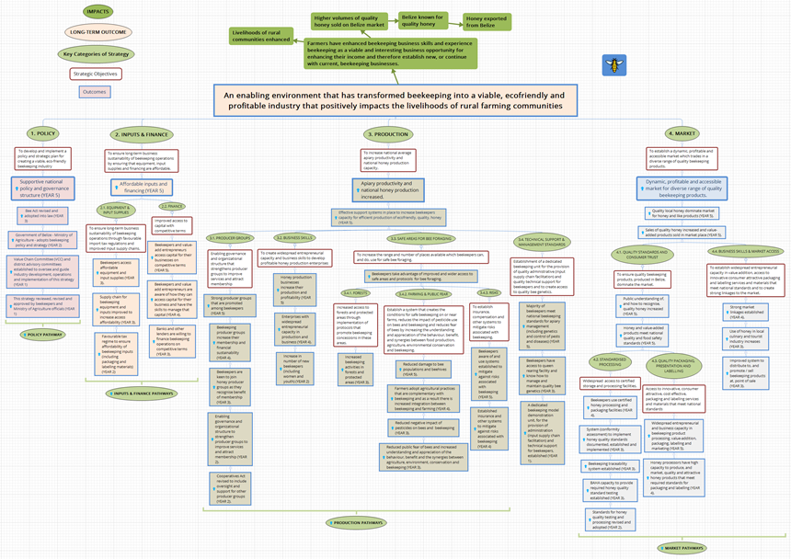

Implementation Plan

The following tables present the implementation plan for the 2020 to 2025 Beekeeping Strategy. The strategic pathways, strategic objectives and outcomes are taken from the theory of change diagram (Fig. ? above) with the activities required to achieve the outcomes inserted underneath. The tables include those accountable for completing the activities, dates for completion, indicators, assumptions and mitigation measures required to address any risks that may prevent successfully implementation.

The numbering system used indicates the order of implementation. For example, in strategic pathway 1.0 Policy Pathway, 1.1. Governance Structure the first activity to be implemented is activity 1.1. The pathway will be completed on completion of activity 4.2.

- POLICY PATHWAY:

- Governance Structure
Strategic Objective: To develop and implement a policy and strategic plan for creating a viable, eco-friendly beekeeping industry.

OUTCOMES & ACTIVITIES |  |  |  |  |  | Who’s  Accountable? |  | With? |  | By When? |  | INDICATORS |  |  | ASSUMPTIONS / RISKS |  |  | RISK MITIGATION
Outcomes
 |  |  |  | Activities
5. Supportive national policy and governance structure (Year 5)
4. Bee act revised and adopted into law with accompanying regulatory framework (Year 4)
 |  |  |  | 4.1. Complete draft beekeeping bill |  | Pro tem strategy team |  |  |  | Year 1 - Nov
 |  |  |  | 4.2. Prepare cabinet paper and present draft bill to Min of Ag. |  | Min of Agriculture / Policy Unit. |  |  |  | Year 2
 |  |  |  | 4.3. Bill adopted into law.
3. Government of Belize – Ministry of Agriculture – adopts beekeeping policy and governance structure (year 2)
 |  |  |  | 3.1. Develop beekeeping policy for submission to cabinet. Include need for dedicated beekeeping unit in national beekeeping policy. |  | Policy Unit / BMDC |  |  |  | Year 1 - June
2. This strategy reviewed, revised and endorsed by beekeepers and Ministry of Agriculture (year 1)
 |  |  | 2.1. Complete strategy document. |  |  | Ad hoc strategy team + policy unit. |  |  |  | Year 1 - Oct
 |  |  | 2.2. Present to Council for approval. |  |  | Council |  |  |  | Year 1 - Nov
1. National beekeeping council established to regulate guide monitor and evaluate industry development, operations and implementation of the strategy (Year 1)
 |  |  |  | - Develop TOR for the Beekeeping (value chain) Council and district advisory committees. |  | Ministry of Agriculture – Dept of Cooperatives. |  |  |  | Year 1 - Aug
 |  |  |  | - Establish / launch Beekeeping Council and District Advisory Committees |  | Dept .of Cooperatives |  |  |  | Year 1 - Sept
 |  |  |  | - Develop a honey industry communication strategy |  | Policy Unit |  |  |  | Year 1 - Nov
1.2 Information System
Strategic Objective: To establish a national beekeeping data and information system to enable strategic policy decision for growth of the industry.

 | OUTCOMES & ACTIVITIES |  |  |  | Who’s  Accountable? |  | With? |  | By When? |  | INDICATORS |  | ASSUMPTIONS / RISKS |  |  | RISK MITIGATION
 | Outcomes
 |  | Activities
 | 2. National traceability system established (Year 3)
 |  | - Necessary legislation to support traceability established (see above). |  |  | Pro tem strategy team |  |  |  | Year 1 - Nov
 |  | - Develop a national traceability guideline. |  |  | MOA |  | BMDC(BAHA / BBS) |  | Year 2
 |  | - Awareness campaign of importance of traceability and standards implemented |  |  | MOA |  | BMDC |  | Year 2
 |  | - Training key stakeholders along the value chain in national traceability protocols. |  |  | BAHA |  | BBS |  | Year 2
 | - National beekeeping registry implemented (Year 2)
 |  | 1.1. Develop TOR for designing and implementing registry (review cattle / sheep / OIRSA systems). |  |  | Mr Howe |  |  |  | Year 1 - Aug
 |  | - Develop registry system. |  |  | TBD - Consultant |  |  |  | Year 1- Dec.
 |  | - Sign MOU for management of registry system of beekeepers. |  |  | MOA |  |  |  | Year 2 - Jan
 |  | - Test registry system in pilot phase. |  |  | MOA |  |  |  | Year 2
 |  | - Launching registry system. |  |  | MOA |  |  |  | Year 2
 |  | - Mandatory registration of honey producers. |  |  | MOA |  |  |  | Year 2

- INPUTS & FINANCE PATHWAY
Strategic Objective: To ensure long-term business sustainability of beekeeping operations by ensuring that equipment, input supplies and financing are affordable.

  - EQUIPMENT & INPUT SUPPLIES:
Strategic Objective: To ensure long-term business sustainability of beekeeping operations through favourable import tax regulations and improved input supply chains.

OUTCOMES & ACTIVITIES |  |  | Who’s Accountable | With? | By When? | INDICATORS | ASSUMPTIONS / RISKS | RISK MITIGATION
Outcomes
 | Activities
3. Beekeepers access affordable equipment and input supplies (YEAR 3).
 |  | 3.1. Facilitate public awareness campaign to inform beekeepers about improved arrangements and systems to access equipment and input supplies. | Bee Council | BMDC, COOPs, MOA | Year 3
2. Supply chain for beekeeping equipment and inputs improved to increase access affordability (YEAR 3).
 |  | 2.1 Inventory of equipment and supplies (including packaging and labelling) materials required, current costs of obtaining such inputs and threshold costs required to ensure affordability | Beekeeping Coordinator | BMDC, | Year 3
 |  | 2.2 Affordable Inputs and alternatives identified and recommendations on accessing and procedures to follow. | Beekeeping Coordinator | BMDC, BELTRAIDE | Year 3
 |  | 2.3. Develop and implement plan to improve supply chain. | Bee Council | Coops | Year 3
 |  | 2.4. Create mechanism to facilitate access to equipment and input supplies through credit agreements. | Bee Council | Coops | Year 3
 |  | 2.5. Link to existing virtual marketing platform for beekeeping product inputs (and products) | BMDC | Policy Unit | Year 2
1. Favourable tax regime to ensure affordability of beekeeping inputs (including packaging and labelling materials) (Year 2).
 |  | 1.1. Government lobbied to modify tax regime to ensure beekeeping inputs are affordable. | Beekeeping Coordinator | BMDC, BELTRAIDE | Year 2
 |  | 1.2. Assessment conducted on equipment and input (including packaging and labelling) supply chains and tax regimes and recommendations made on how to increase affordability. | Beekeeping Coordinator | BMDC, BELTRAIDE | Year 2

  - FINANCE:
Strategic Objective: Improved access to capital with competitive terms.

OUTCOMES & ACTIVITIES |  |  |  | Who’s Accountable | With? | By When? | INDICATORS | ASSUMPTIONS / RISKS | RISK MITIGATION
Outcomes
 |  | Activities
1. Beekeepers and value-add entrepreneurs access capital for their businesses on competitive terms (YEAR 5) |  |  |  | Beekeeping council | MoA | Year 5 | No of Beekeeping related loans approved.
2. Beekeepers and value add entrepreneurs are aware of how they can access capital for their business and have the skills to manage that capital (YEAR 4).
 |  | 2.1. Conduct workshops with beekeepers to create awareness on financing opportunities available for their business |  | Coops | Credit League, RRB, NGOs | Year 3
 |  | 2.2 Train beekeepers and entrepreneurs on financial literacy and business management. |  | Coops | BELTRAIDE | Year 4
3. Banks and other lenders are willing to finance beekeeping operations on competitive terms (YEAR 3)
 |  |  | 3.1Ensure key banks and other lenders have a clear understanding of the risks and potential profitability at different levels of beekeeping operations. | Beekeeping council | Coops | Year 2
 |  |  | 3.2 Meet with lending institutions to determine their perspectives on lending on competitive terms to beekeeping, honey processing enterprises and marketing operations - and educate them about beekeeping risks, profitability and opportunities for investment. | Beekeeping council |  | Year 2.5
 |  |  | 3.3 Develop / facilitate agreements between financial institutions, beekeepers and producer groups and related enterprises for financing under favourable terms. | Beekeeping council |  | Year 3
- Accessibility to reliable beekeeping market and profitability information (YEAR 1)
 |  |  | 3.1. Conduct market research | BMDC |  | Year 1 - Dec
 |  |  | 3.2. Carry out a profitability analysis and establish baseline cost of production. | Beekeeping Coordinator | Cooperatives | Year 1 - Dec
 |  |  | 3.3. Analyze and document productivity challenges of current beekeeping systems (including finances). | Beekeeping Coordinator | Cooperatives. | Year 1 - Dec
 |  |  | 3.4. Analyze barriers to access financing needs. | Registrar of Coops | Consultancy / BEST | Year 1 - Dec

3. PRODUCTION & MANAGAMENT PATHWAYS

Strategic Objective: To increase national average apiary productivity and national honey production capacity (by…..?)

OUTCOMES & ACTIVITIES |  | Who’s Accountable? | With? | By When? | INDICATORS | ASSUMPTIONS / RISKS | RISK MITIGATION
Outcomes
 | Activities
Apiary productivity and national honey production increased.
Effective support systems in place to increase beekeepers capacity for efficient production of eco-friendly, quality, honey (YEAR 5).
 | Establish the federation of beekeeper groups to facilitate synergies for production, processing and marketing of beekeeper products (domestic and export).
 | Establish coordination between producer groups and district advisory committees.

3.1. PRODUCER GROUPS:
Strategic Objective: Enabling governance and organizational structure that strengthens producer groups to improve services and attract membership.

OUTCOMES & ACTIVITIES |  | Who’s Accountable? | With? | By When? | INDICATORS | ASSUMPTIONS / RISKS | RISK MITIGATION
Outcomes
 | Activities
1. Strong producer groups that are promoted among beekeepers (YEAR 5).
1.1 Implement mechanism to recognize and promote successful beekeeping producer groups. |  | Coops | MoA | Year 5
2. Beekeeping producer groups increase their membership and financial sustainability (YEAR 4).
 | 2.1 Conduct beekeeping awareness campaign to promote beekeeping as a viable enterprise | Coops | MoA | Year 4
 | 2.2 Monitor and evaluate of the implementation of the strategic plans developed to ensure sustainability of producer groups. | Coops | MoA | Year 4
 | 2.3 Establish resiliency mechanisms to cope with challenging times. | Coops | MoA | Year 4
3. Beekeepers are keen to join honey producer groups as they recognise benefit of membership YEAR 3).
 | 3.1. Execute an awareness campaign on the new support services and benefits available to entrepreneurs along the value chain. | Bee Council | MoA/Coops | Year 3
4. Enabling governance and organizational structure to strengthen producer groups to improve services and attract membership (YEAR 2).
 | 4.1. Assess and document beekeepers’ perspective on producer groups and determine what services beekeepers would need from producer groups. | Coops | MoA | Year 2
 | 4.2. Strengthen cooperative staff in developing strategic plans/business plans (to include improved services to attract membership) for beekeeping groups to meet minimum requirements of lending institutions. | Coops | MoA | Year 2
 | 4.3. Strengthen leadership and management skills of producer group members. | Coops | MoA | Year 2
 | 4.4. Strategic plans developed and implemented for producer groups. | Coops | MoA | Year 2
 | 4.5. Develop and implement a communication strategy with and for each producer groups to create dialogue, awareness and appreciation of the value of being a cooperative member. | Coops | MoA | Year 2
5. Cooperatives Act revised to include oversight and support for other producer groups (YEAR 2).
 | 5.1. Strengthen legislation to include guidance and support from Coop. Dept to producer groups. | Coops | SolGen | Year 2

  - BUSINESS SKILLS:
Strategic Objective: To create widespread entrepreneurial capacity and business skills to develop profitable honey production enterprises.

OUTCOMES & ACTIVITIES |  | Who’s Accountable? | With? | By When? | INDICATORS | ASSUMPTIONS / RISKS | RISK MITIGATION
Outcomes
 | Activities
3. Honey production businesses increase their production and profitability (YEAR 5)
 | 3.1 Establish and implement a system of annual monitoring and evaluation of the beekeeping enterprises. | Coordinator | Tech Team | Year 1 to 4
- Enterprises with widespread entrepreneurial capacity in production and business. (YEAR 4).
 | 2.1. Provide widespread training to Increase business and entrepreneurial competency and operations of beekeepers. | Coordinator | Coops, BELTRAIDE, NGOs | Year 4
 | 2.2. Explore and promote beekeeping as an agro-ecological tourism activity. | Coordinator | ProducerGroups NGOs | Year 3
 | 2.3. Assess weaknesses of beekeeping enterprises and develop a robust and inspirational training programme. | Coops | MoA | Year 3
- Increase in number of new beekeepers (including women and youth) (YEAR 2)
 | 1.1. Implement training and internship programmes for start-up beekeepers | Bee Coordinator | Tech Team, BAHA, Mentor | Year 2
 | 1.2. Promote beekeeping as a worthwhile and profitable venture to improve family livelihoods. | Bee Coordinator | MoA, Council | Year 2
 | 1.3. Develop training and internship programme - following good management practices - for new beekeepers. | Bee Coordinator | Tech Team, Oirsa, Baha | Year 2
 | - Identify profiles for potential new beekeepers. | Bee Coordinator | Tech Team | Year 1

  - SAFE AREAS FOR BEE FORAGING

Strategic Objective: To increase the range and number of places available which beekeepers can, and do, use for safe bee foraging.

OUTCOMES & ACTIVITIES |  | Who’s Accountable? | With? | By When? | INDICATORS | ASSUMPTIONS / RISKS |  |  | RISK MITIGATION
Outcomes
 | Activities
Beekeepers take advantage of improved and wider access to safe areas and protocols for bee foraging.

3.3.1. FORESTS
Strategic Objective: Increased access to forests and protected areas through implementation of protocols that promote beekeeping concessions in these areas.

OUTCOMES & ACTIVITIES |  | Who’s Accountable? | With? | By When? | INDICATORS | ASSUMPTIONS / RISKS | RISK MITIGATION
Outcomes
 | Activities
1. Increased beekeeping activities in forests and protected areas (YEAR 3)
 | - Establish protocols for beekeeping concessions in forest & protected areas through dialogue with Forestry Department (including logging companies) and conservation stakeholders. | Beekeeping council | NGOs, Forestry, BKU | Year 1
 | - Promote beekeeping, as a component of forest conservation and as an alternative livelihood opportunity for communities close to forest and protected areas. | Beekeeping council | NGOs, Forestry, BKU | On going - Start by Year 1
 | - Develop training programme for sustainable beekeeping as a part of forest and protected area conservation and climate change mitigation. | Beekeeping Council | NGOs, Forestry, BKU | Year 2
 | - Trained beekeepers and forest / protected area managers in "sustainable beekeeping in forest and protected areas" | NGO (protected area managers) | BKU, Forestry. | Year 2
 | - Promote good agricultural practices that are complementary to beekeeping along buffer zones. | NGO (protected area managers) | Min of Agric, Forestry, PCB, BBS (?) | On going - Start by Year 3
 | - Promote beekeeping in areas not suitable for agriculture (for e.g. mangroves and on sloping lands above 22% to provide alternative income to agriculture and so reduce land degradation). | BKU | MOA (livestock)  BLPA  NGO | Year 2
 | 1.7 Develop a floral calendar | Forestry | ERI  NGO | Year 3
 | 1.8 Research on Impact of Climate change on forest and protected areas and its effects in Beekeeping. | Beekeeping council | MOA  Universities  Forestry | Year 3

    - FARMING & PUBLIC FEAR

Strategic Objective: Establish a system that creates the conditions for safe beekeeping on or near farms, reduces the impact of pesticide use on bees and beekeeping and reduces fear of bees by increasing the understanding and appreciation of the behaviour, benefit, and synergies between food production, agriculture, environmental conservation and beekeeping.

OUTCOMES & ACTIVITIES |  | Who? | With? | By? | INDICATORS | ASSUMPTIONS / RISKS | RISK MITIGATION
Outcomes
 | Activities
4. Reduced damage to bee populations and beehives (YEAR 5).
 | - Asses change of public knowledge and attitude towards bees. | Beekeeping council | UB  MOA  BKU | Year 5
 | 1.2. Determine the number of integrated beekeeping farms or apiary near farms. | Beekeeping council | MOA | Year 1  Year 5
3. Farmers adopt agricultural practices that are complementary with beekeeping and as a result there is increased integration between beekeeping and farming (Year 4).
 | 3.1. Assess the challenges and opportunities for beekeeping near other farming activities. | BKU | Beekeeping council | Year 2
 | 3.2. Design and implement an agro-forestry and reforestation program compatible with beekeeping. | BKU | Beekeeping council  MOA  Forestry | Year 3
 | 3.3. Develop guidelines and train farmers on sustainable integrated farming systems that are complementary to beekeeping. | BKU | MOA | Year 2
 | 3.4. Promote the integration of beekeeping in established farms through the promotion of bee friendly agricultural practices. | BKU | MOA | Year 2
 | 3.5. Promote agreements that are complementary to both beekeepers and farmers such as pollination service. | BKU | MOA  Coops, EX | Year 2
 | 3.6. Develop and promote pollination service protocols and training programme. | Beekeeping council | MOA | Year 3
 | 3.7. Develop protocols for beekeeping practices near farmland. | Beekeeping council | BKU | Year 2
 | 3.8. Develop agro-forestry demonstration modules complimentary to beekeeping that can be adopted by livestock producers and forest protected area managers. | BKU | CF  SC  Tol | Year 3
 | 3.9. Revise Bee Act to include compensation mechanism for loss of bee population due to poor farming practices or other negligent activities to bees. | MOA  Policy Unit | Beekeeping council | Year 3
- Strengthen pesticide use monitoring and promote use of alternative pesticides that do not harm bees and beekeeping (YEAR 3).
 | - Evaluate current pesticide regulations and provide recommendations for the enforcement of bee-friendly pesticide use. | Beekeeping council | PCB | Year 2
 | - Strengthen the monitoring capacity of the pesticide review committee to manage the importation of bee friendly pesticides. | PCB | Beekeeping council  MOA | Year 2
 | - Promote proper management and disposable of empty containers to reduce exposure of bees to contaminants. | Beekeeping council | PCB  MOA | Year 2
 | - Identify and implement mechanisms for improved regulations of pesticide use to reduce impact of pesticides on bee populations and honey quality. | Beekeeping council | PCB  MOA | Year 2
 | - Strengthen the capacity of competent authority (BAHA) to test for pesticide residues in honey and beekeeping by products. | BAHA | MOA | Year 3
 | - Identify and regulate the use of alternative bee-friendly pesticides. | PCB | Beekeeping council | Year 3
 | - Implement a public awareness campaign to promote the use of bee friendly pesticides. | Beekeeping council | PCB  MOA  BMDC | Year 1
1. Reduced public fear of bees and increased understanding and appreciation of the behavior, benefit and the synergies between agriculture, environment, conservation and beekeeping (YEAR 3).
 | - Implement a national bee appreciation (agricultural, environmental and conservation synergies) and awareness campaign outlining the benefits of bees to society and bee recognition and safety procedures. | Beekeeping council | BMDC  BKU | Year 1
 | - Assessment of public knowledge and attitude towards bees and recommendations on how to reduce public fear and improve bee safety. | Beekeeping council | BMDC  BKU | Year 1

    - RISKS

Strategic Objective: To establish insurance, compensation and other systems to mitigate risks associated with beekeeping.

OUTCOMES & ACTIVITIES |  | Who? | With? | By? | INDICATORS | ASSUMPTIONS / RISKS |  | RISK MITIGATION
Outcomes
 | Activities
2. Beekeepers aware of and use systems established to mitigate against risks associated with beekeeping (YEAR 5).
 | 2.1. Increase capacity of beekeepers to mitigate against beekeeping risks and to access benefits through the system established to assist in the event of disaster. | Beekeeping council | MOA  Coops  BKU | Year 5
1. Established insurance and other systems to mitigate against risks associated with beekeeping (YEAR 4)
 | - Establish a bee-hive registration and traceability system to discourage larceny. | BKU | BAHA MOA  OIRSA | Year 2
 | - Implement an anti-theft public awareness campaign to reduce theft incidence. | Beekeeping council | MOA BKU | Year 1
 | - Lobby with insurance providers, Ministry of Agriculture officials and producer groups for insurance or compensation fund. | Beekeeping council | MOA  BMDC  Coops | Year 3
 | - Include beekeeper insurance as part of national initiative for and agricultural insurance programme. | Beekeeping council | MOA  Coops | Year 4
 | - Asses the feasibility of establishing a beekeeping industry fund, and the nature of such a fund, that will provide compensation in the event of disaster. | Beekeeping council | UB | Year 3
 | - Asses risks associated with beekeeping (fire, hurricane, theft etc.) and recommend mechanisms to mitigate against such risks. | Beekeeping council | MOA  BKU | Year 3

3.4. TECHNICAL SUPPORT & MANAGEMENT STANDARDS

3.4.1. Technical Support
Strategic Objective: To establish a dedicated beekeeping unit for the provision of quality administrative (input supply chain facilitation) and quality technical support for beekeepers and to create access to quality bee genetics.

OUTCOMES & ACTIVITIES |  | Who? | With? | By? | INDICATORS |  | ASSUMPTIONS / RISKS |  | RISK MITIGATION
Outcomes
 | Activities
5. Majority of beekeepers meet national beekeeping standards for apiary management (including genetics and control of pests and diseases) (YEAR 5)
 | 5.1. Implement an on-going training schedule and programme on GMPs for beekeepers. | BKU | MOA  BAHA  OIRSA  CEMJC  UB | Year 3
 | 5.3. Establish a GMP certification system (which includes product traceability). | BAHA | BKU  Beekeeping Council | Year 5
 | 5.4. Develop and Implement a National Pest and Disease management strategy. | BKU | BAHA | Year 3
 | 5.5. Establish and implement a national pest and disease (of Economic importance) surveillance and awareness program. | BAHA | BKU, OIRSA | Year 2
 | 5.6. Develop and Implement a movement control system for bee hives. | BAHA | BKU, MOA | Year 3
4. Beekeepers have access to queen rearing facility and know how to manage and maintain quality bee genetics (YEAR 3).
 | 4.1. Train technicians and beekeepers in managing beehive genetics as part of good management practices. | BKU | CEMJC  UB  MOA | Year 2
 | 4.2. Develop bee genetics manual and training materials. | BKU | CEMJC  UB  MOA | Year 2
 | 4.3. Establish access for beekeepers to queen rearing – quality bee genetics facility (not necessarily in Belize). | BKU | MOA  OIRSA  BAHA | Year 3
 | 4.4. Network with regional beekeeping institutions and keep up to date in genetic improvement of bees. | BKU | MOA  OIRSA  BAHA | Year 3
3. A functional beekeeping production data and information system
 | 1.1 Enhance and capture beekeeping production data into BAIMS | BKU | BAIMS-PU | Year 1
 | 1.2 Establish and implement a National Beekeeping traceability System. | BKU | OIRSA  BAHA  BMDC  MOA  IICA | Year 3
 | 1.3 Implement a National Beekeepers and Apiary Registration System. | BKU | OIRSA  BAHA  BMDC  MOA  IICA | Year 2
- Strategically places model demonstration units for the provision of technical support for beekeepers across the country (YEAR 2)
 | 1.1 Establish a national training and demonstration apiary unit at Central Farm | BKU | MOA | Year 1
 | 1.2 Establish two regional training and demonstration apiaries at Stann Creek and CEMJC (MOU). | BKU | MOA  CEMJC  UB | Year 2
1. A dedicated beekeeping unit, for the provision of administrative and technical assistance to beekeeping stakeholders. (YEAR 1)
 | 1.1. Develop term of reference for beekeeping unit (Note: which should include, keeping abreast of latest beekeeping technology and researching applicability to Belize, research into alternative bees that can produce honey of high market value (e.g. Melipona), establishing beekeeping zone protocols for optimum bee foraging and hive movement, lobbying with pubic work for upkeep of apiary access roads, repository of beekeeping literature) | MOA | BKU | Year 1 -Sept.
 | 1.2. Develop a work-plan using the strategy as a guide (including managing of demonstration apiary). | MOA/BKU | BMDC  Coops  IICA  CDF-PSC | Year 1-  Sept.
 | - Establish and fully equip a dedicated beekeeping unit and extension service. | BKU | CDF-PSC  MOA | Year 1
 | - Develop and implement a national M & E system for the implementation of the strategy. | MOA  M&E | BKU  Beekeeping Council | Year 1,3,5
 | - Develop capacity building plan for unit staff and extension in administrative, organization and technical issues. | BKU | MOA | Year 1  -Dec
 | - Develop a response system and network of beekeepers specialized in capturing feral swarms – to reduce the risk to the public. | BKU | MOA  Beekeeping Council | Year 2  -July

3.4.2. Standards
Strategic Objective: To establish a strong monitoring and auditing mechanism to ensure implementation of good production practices.

OUTCOMES & ACTIVITIES |  | Who? | With? | By? | INDICATORS | ASSUMPTIONS / RISKS | RISK MITIGATION
Outcomes
 | Activities
2. A national quality assurance scheme.
 | - Design a national quality assurance monitoring and inspection system (GBP and GMP). | BKU | MOA  IICA  BMDC  BAHA | Year 1
 | - Implement the pilot quality assurance system. | BKU | MOA  IICA  BMDC | Year 1
 | - Review honey standard. | Beekeeping Council | BKU  BMDC  BBS  BAHA  MOA | Year 3
 | - Implement awareness and training programme on quality assurance system. | BKU | BMDC  MOA | Year 2
1. A good beekeeping practices standard (YEAR 2).
 | 1.1. Review and adopt national beekeeping practices standard. | BKU | MOA | Year 1 -Oct
 | 1.2. Review and Publish a “Good beekeeping practices” guide (hard, digital and video) | BKU | MOA, CARDI, | Year 2
 | 1.3. Develop robust multi-level training program/ curriculum on Good Beekeeping Practices. | BKU | MOA, BAHA, CEMJC,UB | Year 1

4. MARKET PATHWAYS

Strategic Objective: To establish a dynamic, profitable and accessible market which trades in a diverse range of quality beekeeping products.

OUTCOMES & ACTIVITIES |  | Who? | With? | By? | INDICATORS | ASSUMPTIONS / RISKS | RISK MITIGATION
Outcomes
 | Activities
Dynamic, profitable and accessible market which trades in a diverse range of quality beekeeping products
Quality local honey dominate market for honey and honey like products (Year 5).
Sales of quality honey increased (YEAR 5).

4.1. QUALITY STANDARDS AND CONSUMER TRUST
Strategic Objective: To ensure quality monitoring systems that ensure beekeeping products produced in Belize dominate the market

OUTCOMES & ACTIVITIES |  | Who? | With? | By? | INDICATORS | ASSUMPTIONS / RISKS | RISK MITIGATION
Outcomes
 | Activities
4. Sales of quality honey increased
3. Public understanding of, and recognition of, quality honey increased (YEAR 5).
 | 3.1. Widespread promotion of how to identify Belizean quality beekeeping products.
 | 3.2. Establish and use a competent authority ‘certification stamp of approval’
2. Honey and value-added products meet national quality and food safety standards (YEAR 5).
1. Established quality assurance registration and monitoring systems for beekeeping (YEAR 5).

4.1.1. STANDARDISED PROCESSING
Strategic Objective: Honey producers have widespread access to certified storage and processing facilities.

OUTCOMES & ACTIVITIES |  | Who? | With? | By? | INDICATORS | ASSUMPTIONS / RISKS |  | RISK MITIGATION
Outcomes
 | Activities
5. Beekeepers use certified honey processing and packaging facilities (YEAR 4).
 | 5.1. Promote certification of processing and packaging of honey facilities. | BAHA | Beekeeping Council  MOA | Year 3
 | 5.2. Train honey processors in GMP and how to meet quality honey standards (including how to use quality honey standard testing facilities) | BAHA | Coops  BMDC | Year 3
 | 5.3. Establish processing and packaging facilities established in strategic locations following GMP. | BMDC | BAHA  Coops  MOA | Year 3
 | 5.4. Develop a GMP compliant honey packing and processing facility design. | BAHA | Coops  BMDC | Year 2
 | 5.. Develop a GMP compliant extraction facility for beekeepers. | BAHA | Coops  BMDC | Year 2
4. BAHA capacity to provide required honey quality testing established (YEAR 3)
 | 4.1. Strengthen capacity of BAHA to implement required food safety regulations (testing laboratory) | Beekeeping Council | BAHA | Year 3
 | 4.2. Fully equip BAHA food safety unit to conduct honey analysis. | Beekeeping Council | BAHA  MOA | Year 3
3. System (conformity assessment) to implement honey quality standards documented, established and implemented (YEAR 3).
 | 3.1. Implement national honey standards. | BAHA | BBS  MOA | Year 3
 | 3.2. Train stockholders on national honey and by product processing standards. | Beekeeping Council | BAHA | Year 3
2. Beekeeping traceability system established (YEAR 3)
1. Standards for honey quality and GMP for processing revised and approved (YEAR 2).
 | 1.1. Document and establish good manufacturing practices for beekeeping product enterprises. | BAHA | BKU  BMDC | Year 2
 | 1.2 Establish food safety standard for honey extraction and handling. | BKU | BAHA  BMDC | Year 2

4.1.2. QUALITY PACKAGING, PRESENTATION AND LABELLING
Strategic Objective: Honey producers have widespread access to innovative, consumer attractive, cost effective, packaging and labelling services and materials that meet national standards.

OUTCOMES & ACTIVITIES |  | Who? | With? | By? | INDICATORS | ASSUMPTIONS / RISKS | RISK MITIGATION
Outcomes
 | Activities
2. Widespread entrepreneurial and business capacity in beekeeping product processing, value-addition, labelling and marketing (YEAR 5).
 | - Provide business and entrepreneurial training for development of beekeeping product enterprises focused on processing, branding, value addition, market dynamics and marketing. | BMDC | Beltraide, MOA,Coops,Best,NGO,BAHA | Year4
 | - Establish a fund (derived from contributions of agricultural commodity importers and other donors) for start-up capital for agricultural entrepreneurs. | BMDC | MOA | Year 3
 | - Develop a comprehensive beekeeping products value-chain business and entrepreneurial training program (Based on assessment of market and capacity strengthening needs.) | BMDC | MOA, Beltraide, Coops | Year 3
 | - Promote value addition opportunities along the value chain (including women and youth and non-beekeepers) | Agro Processing Unit | BKU,BMDC, MOA | Year 4
 | - Assess honey packers and processors business capacity and identify areas where strengthening is required. | BMDC | MOA, Coops | Year 3
 | - Conduct and assessment market opportunities (domestic, tourist and export) and market requirements for honey and value-added honey products. | BMDC | Coops, Beltraide | Year 2
1. Honey processors have high capacity to produce and market, quality and attractive honey products that meet required standards for packaging and labelling (YEAR 4).
 | 1.1. Develop and implement a training programme for packaging and labelling of beekeeping products that are consumer attractive and that meet market standards. | BMDC | BBS | Year 2
 | 1.2. Ensure honey processors have access to innovative customer attractive, cost effective, packaging and labelling services and materials that meet international standards. | BMDC | BBS  Beltraide | Year 2
 | 1.3. Examine supply chains for packaging and labelling materials and make recommendations for improvements, to ensure availability and affordability. | BMDC | Beltraide  IFAD | Year 2

4.2. BUSINESS SKILLS & MARKET ACCESS
Strategic Objective: To establish widespread entrepreneurial capacity in value addition, access to innovative consumer attractive packaging and labelling services and materials that meet national standards and to create strong linkages to the market.

OUTCOMES & ACTIVITIES |  | Who? | With? | By? | INDICATORS | ASSUMPTIONS / RISKS | RISK MITIGATION
Outcomes
 | Activities
3. Strong market linkages established (YEAR 4).
2. Use of honey in local culinary and tourist industry increases (YEAR 3).
 | - National beekeeping products marketing campaign and strategy developed and implemented (highlighting benefits and true value of honey and beekeeping products).
 | - Conduct survey to determine consumer preferences for honey and honey like products.
1. Improved system to distribute to, and promote / sell beekeeping products at, point of sale (YEAR 3).
 | 1.1. Develop “Belize honey display stands” and position them in strategic locations at sales outlets.
 | 1.2. Lobby and arrange with market outlets to improve shelf-placement of honey and beekeeping products.
 | 1.3. Establish a virtual marketing platform for beekeeping products (and inputs)
 | 1.4. Implement plan to improve system for distributing honey and beekeeping products.
 | - Examine current honey distribution system and make recommendations for improvement.

